

# Rossmoyne Senior High School

### Semester One Examination, 2016

### Question/Answer Booklet

# MATHEMATICS

**SOLUTIONS**

**SPECIALIST**

**UNIT 3**

## Section Two:

## Calculator-assumed

|  |  |  |  |  |  |  |  |  |
| --- | --- | --- | --- | --- | --- | --- | --- | --- |
| Student Number: In figures |  |  |  |  |  |  |  |  |

In words

Your name

## Time allowed for this section

Reading time before commencing work: ten minutes

Working time for section: one hundred minutes

## Materials required/recommended for this section

***To be provided by the supervisor***

This Question/Answer Booklet

Formula Sheet (retained from Section One)

***To be provided by the candidate***

Standard items: pens (blue/black preferred), pencils (including coloured), sharpener, correction fluid/tape, eraser, ruler, highlighters

Special items: drawing instruments, templates, notes on two unfolded sheets of A4 paper, and up to three calculators approved for use in the WACE examinations

## Important note to candidates

No other items may be taken into the examination room. It is **your** responsibility to ensure that you do not have any unauthorised notes or other items of a non-personal nature in the examination room. If you have any unauthorised material with you, hand it to the supervisor **before** reading any further.

## Structure of this paper

|  |  |  |  |  |  |
| --- | --- | --- | --- | --- | --- |
| Section | Number of questions available | Number of questions to be answered | Working  time (minutes) | Marks available | Percentage of exam |
| Section One:  Calculator-free | 7 | 7 | 50 | 53 | 35 |
| Section Two:  Calculator-assumed | 12 | 12 | 100 | 98 | 65 |
|  | | | **Total** | 151 | 100 |

## Instructions to candidates

1. The rules for the conduct of examinations are detailed in the school handbook. Sitting this examination implies that you agree to abide by these rules.
2. Write your answers in this Question/Answer Booklet.
3. You must be careful to confine your response to the specific question asked and to follow any instructions that are specified to a particular question.
4. Spare pages are included at the end of this booklet. They can be used for planning your responses and/or as additional space if required to continue an answer.

* Planning: If you use the spare pages for planning, indicate this clearly at the top of the page.
* Continuing an answer: If you need to use the space to continue an answer, indicate in the original answer space where the answer is continued, i.e. give the page number. Fill in the number of the question that you are continuing to answer at the top of the page.

1. **Show all your working clearly**. Your working should be in sufficient detail to allow your answers to be checked readily and for marks to be awarded for reasoning. Incorrect answers given without supporting reasoning cannot be allocated any marks. For any question or part question worth more than two marks, valid working or justification is required to receive full marks. If you repeat any question, ensure that you cancel the answer you do not wish to have marked.
2. It is recommended that you **do not use pencil**, except in diagrams.
3. The Formula Sheet is **not** to be handed in with your Question/Answer Booklet.

Section Two: Calculator-assumed 65% (98 Marks)

This section has**twelve (****12)** questions. Answer **all** questions. Write your answers in the spaces provided.

Working time for this section is 100 minutes.

Question 8 (5 marks)

Consider the function .

(a) Explain why it is necessary to restrict the natural domain of f in order that its inverse is also a function. (1 mark)

|  |
| --- |
| **Solution** |
| is not a one-to-one function for |
| **Specific behaviours** |
| ✓ explains function is not one-to-one over natural domain |

(b) State a minimal restriction to the domain of f that includes , and then use this restriction to show that . (4 marks)

|  |
| --- |
| **Solution** |
| f has a turning point at (2, -4) and so minimal restriction is  to include |
| **Specific behaviours** |
| ✓ states minimal restriction to domain that includes  ✓ completes square on RHS, adjusting LHS  ✓ chooses, with reason, +ve root  ✓ states inverse |

Question 9 (5 marks)

(a) Let z be a non-zero complex number located in the complex plane. Describe the linear transformation(s) required to transform z to each of the following locations:

(i) 2z. (1 mark)

|  |
| --- |
| **Solution** |
| Dilation of scale factor 2 about the origin. |
| **Specific behaviours** |
| ✓ states dilation with scale factor and centre |

(ii) . (1 mark)

|  |
| --- |
| **Solution** |
| Rotation of 270° anticlockwise about origin. |
| **Specific behaviours** |
| ✓ states rotation with angle and centre |

(b) Consider the complex number z shown in the Argand diagram below. Add to the diagram the location of u, v and w where ,  and . (3 marks)

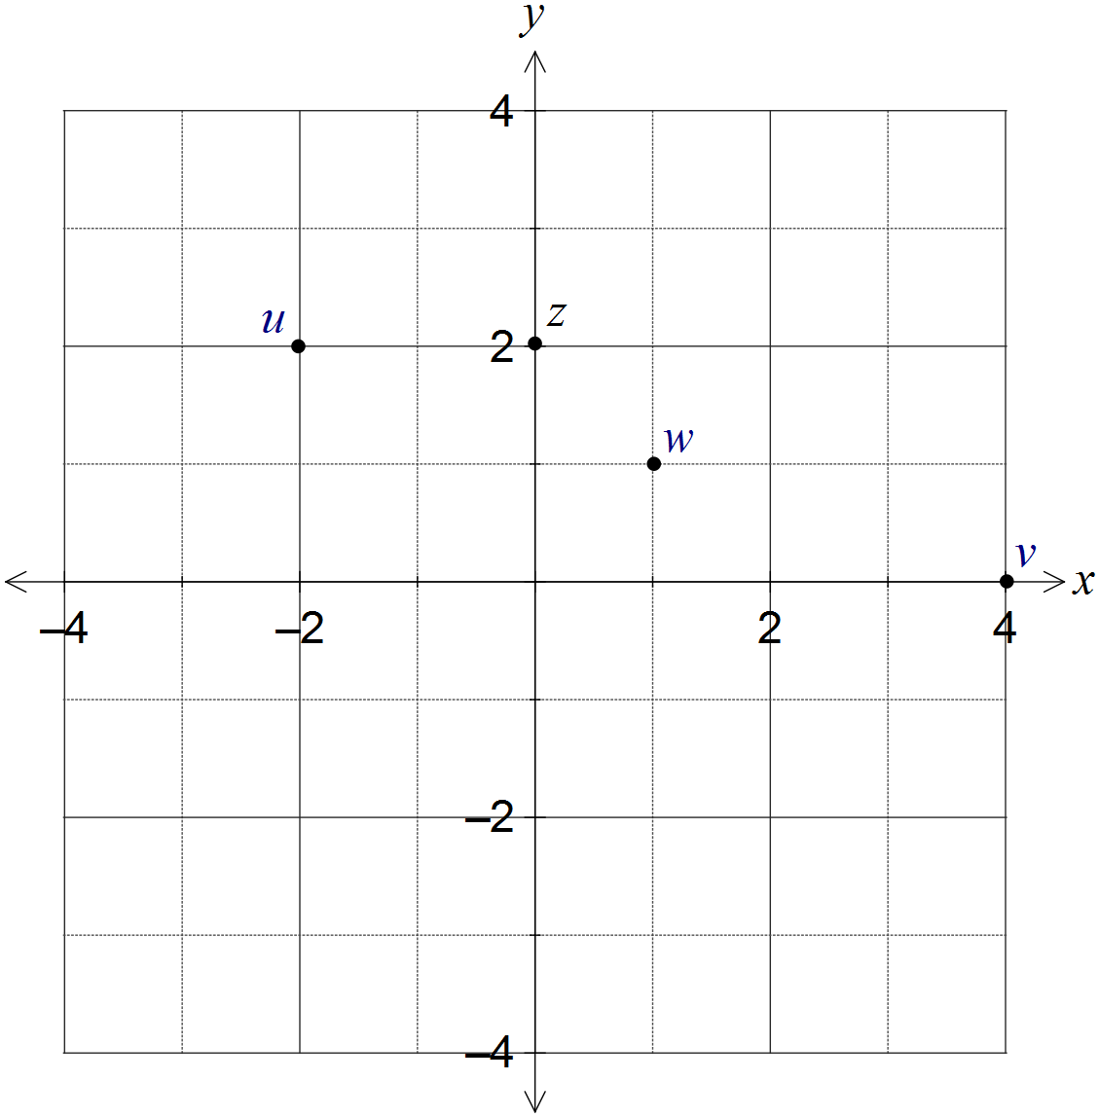

|  |
| --- |
| **Solution** |
| See diagram |
| **Specific behaviours** |
| ✓ places u correctly  ✓ places v correctly  ✓ places w correctly |

Question 10 (8 marks)

Two functions are given by  and .

(a) Determine  and state the domain and range of this composite function. (3 marks)

|  |
| --- |
| **Solution** |
|  |
| **Specific behaviours** |
| ✓ writes simplified composite function  ✓ states domain  ✓ states range |

(b) Show that the composite function  is defined for . (3 marks)

|  |
| --- |
| **Solution** |
|  |
| **Specific behaviours** |
| ✓ substitutes g into f  ✓ simplifies root of square as absolute value  ✓ shows piecewise definition for all real x |

(c) Sketch the graph of  on the axes below. (2 marks)

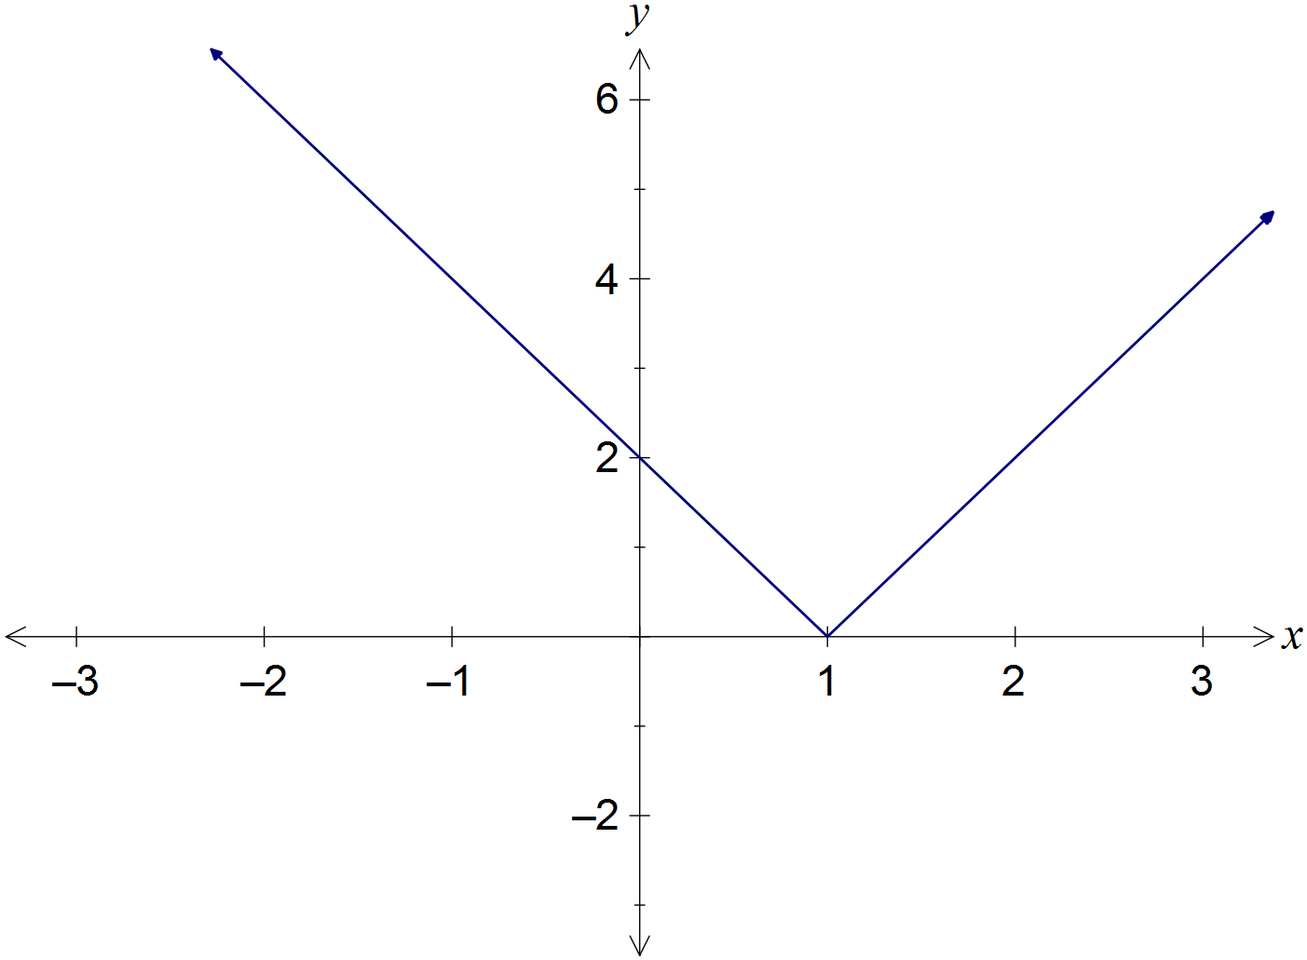

|  |
| --- |
| **Solution** |
| See diagram |
| **Specific behaviours** |
| ✓ all axes intercepts  ✓ shows two parts of composite function |

Question 11 (12 marks)

(a) The graph of  is shown below.

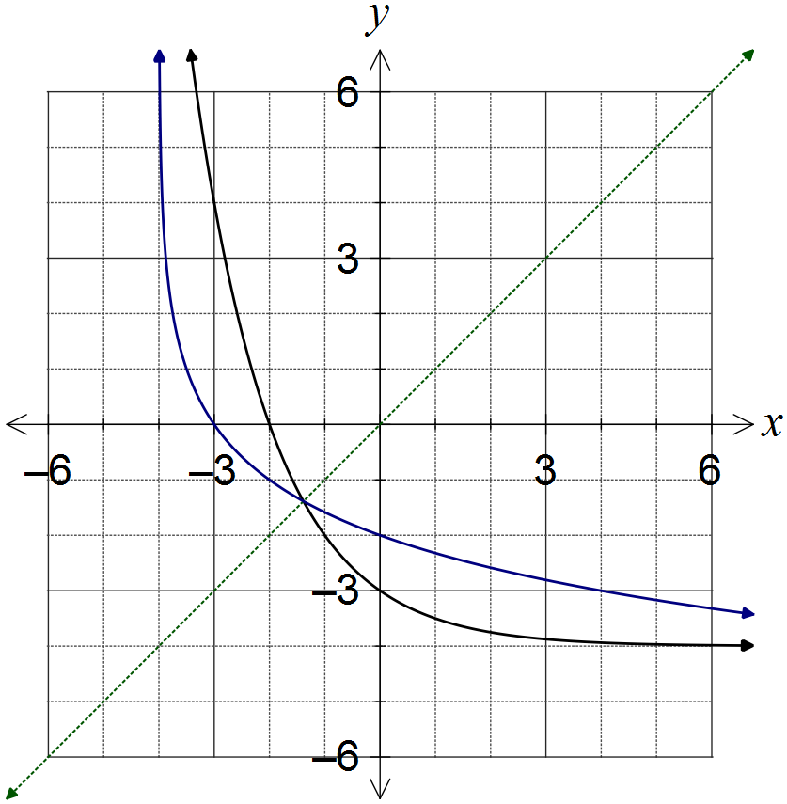

|  |
| --- |
| **Solution** |
| (ii) See diagram |
| **Specific behaviours** |
| ✓ both axes intercepts shown correctly  ✓ curve approaches vertical asymptote  ✓ smooth curve with  as mirror line |

(i) What feature of the graph suggests that the inverse of f is a function? (1 mark)

|  |
| --- |
| **Solution** |
| The part of the graph shown is clearly one-to-one using the horizontal line test. |
| **Specific behaviours** |
| ✓ describes function as one-to-one using graph feature |

(ii) On the same axes, sketch the graph of the inverse of f, . (3 marks)

(b) The graph of  is shown below.

On the same axes, sketch the graph of . (3 marks)

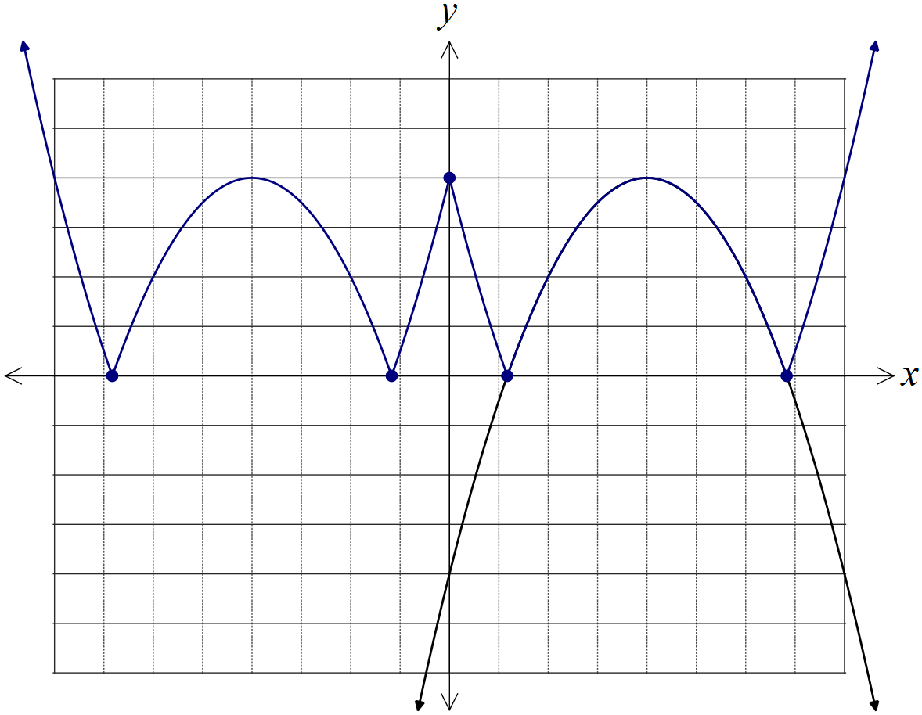

|  |
| --- |
| **Solution** |
| See diagram |
| **Specific behaviours** |
| ✓ reflects , in vertical axis to get  ✓ reflects in horizontal axis  ✓ all five indicated points in correct position |

(c) The graph of  is shown below. As . On the same axes, sketch the graph of , clearly indicating all vertical and horizontal asymptotes.

(5 marks)

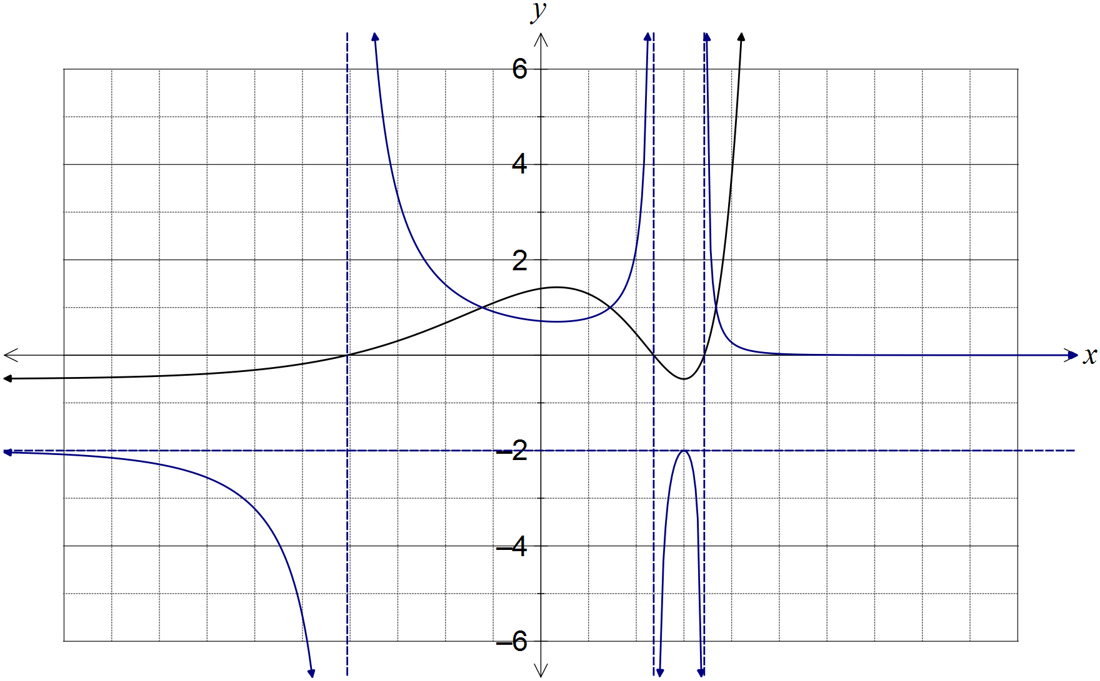

|  |
| --- |
| **Solution** |
| See diagram |
| **Specific behaviours** |
| ✓ correctly shows two parts of curve approaching horizontal asymptotes  ✓ correctly shows parts of curve approaching vertical asymptotes  ✓ correctly shows h and its reciprocal intersect three times when  ✓ uses y-axis scale to locate min and max correctly  ✓ smooth curves used throughout |

Question 12 (8 marks)

(a) Determine all roots of the equation , expressing them in exact polar form  where  and . (5 marks)

|  |
| --- |
| **Solution** |
|  |
| **Specific behaviours** |
| ✓ expresses equation in polar form  ✓ expresses first root with correct modulus  ✓ expresses first root with correct argument  ✓ determines argument between roots  ✓ lists remaining five roots |

(b) Show all solutions of the equation on the Argand diagram below. (3 marks)

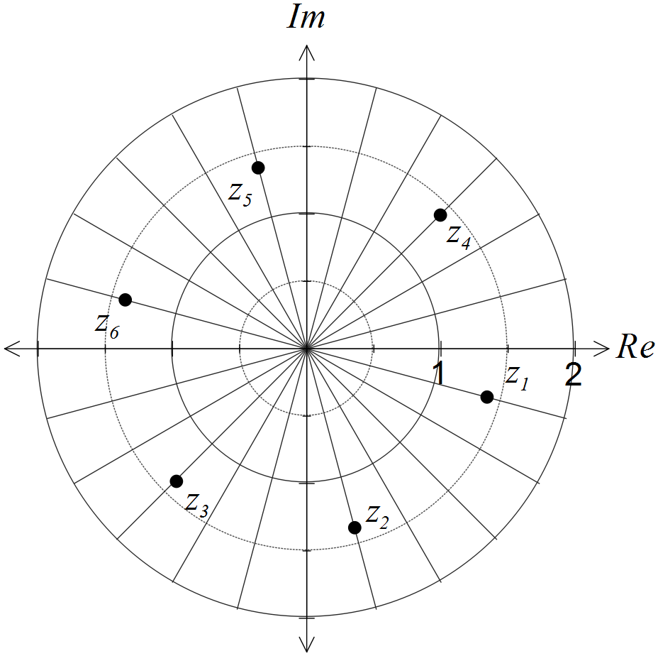

|  |
| --- |
| **Solution** |
| See diagram - six equally spaced points on circle |
| **Specific behaviours** |
| ✓ locates roots with  ✓ locates first root with correct argument  ✓ correctly spaces other five roots |

Question 13 (7 marks)

Two small bodies, A and B, simultaneously leave their initial positions of  and , and move with constant velocities of  and  respectively.

(a) Determine whether the paths of the bodies cross or if the bodies meet. (4 marks)

|  |
| --- |
| **Solution** |
| Paths of bodies do not cross, so bodies do not meet. |
| **Specific behaviours** |
| ✓ describe paths as vector equations  ✓ equate coefficients  ✓ states equations inconsistent/have no solutions  ✓ interprets that paths do not cross |

(b) At the same time, a third small body, C, leaves its initial position, passes through the origin and crosses the path of body A. If C moves with a steady velocity of , determine the value of the constant a. (3 marks)

|  |
| --- |
| **Solution** |
|  |
| **Specific behaviours** |
| ✓ describe path of C as vector equation  ✓ equate coefficients  ✓ states value of a is 2.5 |

Question 14 (9 marks)

The function f is defined by.

(a) Determine the natural domain and range of . (4 marks)

|  |
| --- |
| **Solution** |
|  |
| **Specific behaviours** |
| ✓ factorises and simplifies f  ✓ states domain  ✓ states range using asymptote  ✓ includes 'hole' at (1, -2) in range |

(b) Show that the function has no stationary points. (2 marks)

|  |
| --- |
| **Solution** |
|  |
| **Specific behaviours** |
| ✓ states  ✓ shows cannot be zero |

(c) Sketch the graph of  on the axes below. (3 marks)

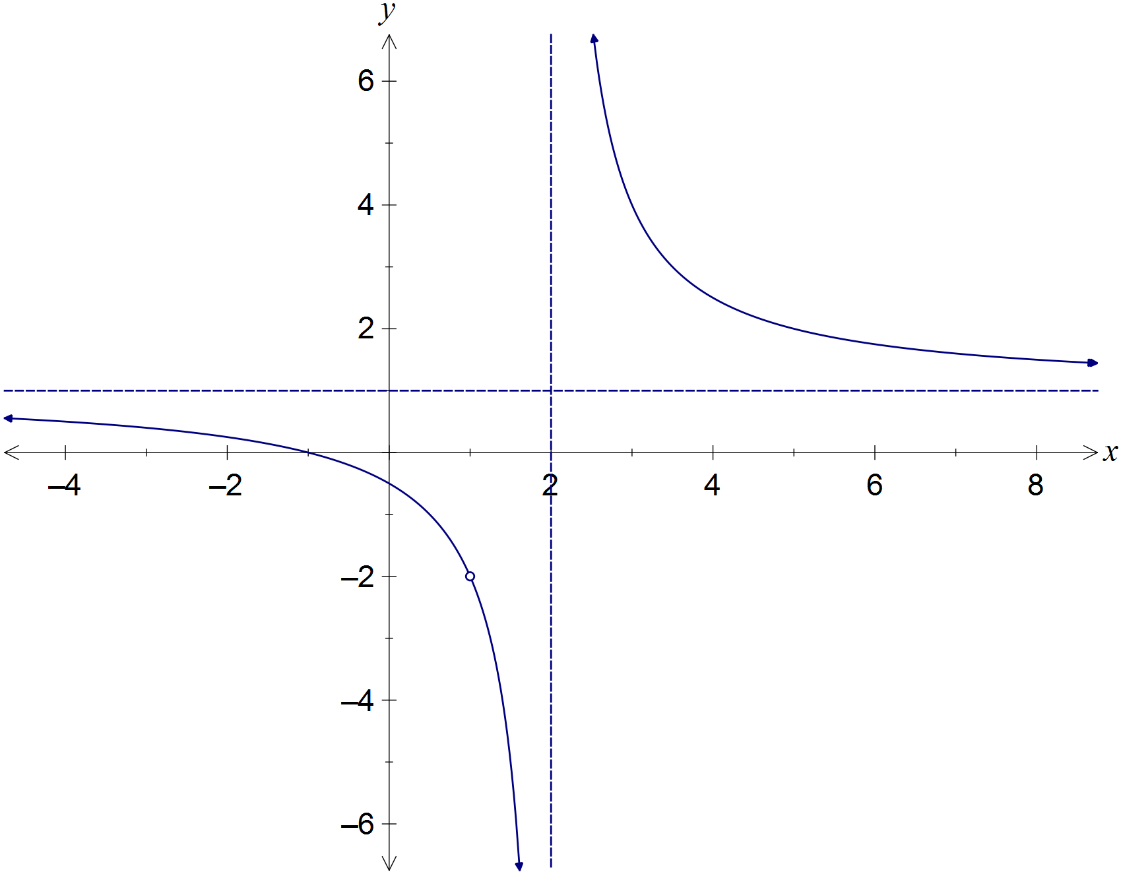

|  |
| --- |
| **Solution** |
| See diagram |
| **Specific behaviours** |
| ✓ axes intercepts  ✓ smooth curves approach asymptotes correctly  ✓ indicates undefined point |

Question 15 (8 marks)

Given the two complex numbers  and , determine the following in terms of the non-zero constants r, s,  and :

(a) . (1 mark)

|  |
| --- |
| **Solution** |
|  |
| **Specific behaviours** |
| ✓ determines argument |

(b) . (2 marks)

|  |
| --- |
| **Solution** |
|  |
| **Specific behaviours** |
| ✓ simplifies into  form  ✓ states modulus |

(c) . (2 marks)

|  |
| --- |
| **Solution** |
|  |
| **Specific behaviours** |
| ✓ simplifies into  form  ✓ determines modulus |

(d) . (3 marks)

|  |
| --- |
| **Solution** |
|  |
| **Specific behaviours** |
| ✓ writes  and  in cis form  ✓ simplifies into  form  ✓ determines argument |

Question 16 (7 marks)

Consider the three vectors ,  and .

(a) Prove that the three vectors do not lie in the same plane. (4 marks)

|  |
| --- |
| **Solution** |
| If vectors lie in the same plane, then a vector perpendicular to **a** and **b** will also be perpendicular to **c**.  Vector perpendicular to **a** and **b** is **d**:    Consider scalar product of **c** and **d**:    Since this is not zero, then **c** and **d** are not perpendicular, and so we conclude that the three vectors cannot lie in the same plane. |
| **Specific behaviours** |
| ✓ chooses cross product to find a perpendicular  ✓ calculates perpendicular correctly  ✓ chooses scalar product to show perpendicular not perpendicular to other vector  ✓ shows scalar product is not 0 |

(b) Determine the value(s) of the constant a if the vector  lies in the same plane as vectors  and . (3 marks)

|  |
| --- |
| **Solution** |
|  |
| **Specific behaviours** |
| ✓ calculates scalar product  ✓ solves scalar product equal to zero  ✓ determines all values of a |

Question 17 (9 marks)

Let the complex number .

(a) Show that . (2 marks)

|  |
| --- |
| **Solution** |
|  |
| **Specific behaviours** |
| ✓ uses De Moivre's theorem to obtain  ✓ uses trig identity to obtain result |

(b) Show that . (2 marks)

|  |
| --- |
| **Solution** |
|  |
| **Specific behaviours** |
| ✓ uses De Moivre's theorem to obtain triple angles  ✓ simplifies result |

(c) Determine  in terms of  and .

(3 marks)

|  |
| --- |
| **Solution** |
|  |
| **Specific behaviours** |
| ✓ expands  ✓ expands  ✓ simplifies imaginary part |

(d) Express  in terms of  and . (2 marks)

|  |
| --- |
| **Solution** |
| Using results from (b) and (c): |
| **Specific behaviours** |
| ✓ equates and eliminates  from results in (b) and (c)  ✓ simplifies and rearranges for required result |

Question 18 (13 marks)

The velocity vector of a particle at time t seconds is , for . When , the particle has position vector .

(a) Calculate the exact speed of the particle when . (2 marks)

|  |
| --- |
| **Solution** |
|  |
| **Specific behaviours** |
| ✓ determines the velocity vector  ✓ calculates the exact speed |

(b) Determine the acceleration vector of the particle and comment on its direction. (2 marks)

|  |
| --- |
| **Solution** |
| Acceleration has no **i** component, so always acts parallel to y-axes. |
| **Specific behaviours** |
| ✓ differentiates velocity vector  ✓ states always acts parallel to y-axis, or vertically |

(c) Determine the position vector of the particle for . (2 marks)

|  |
| --- |
| **Solution** |
|  |
| **Specific behaviours** |
| ✓ integrates velocity vector  ✓ evaluates constants and includes in position vector |

(d) Derive the Cartesian equation of the path of the particle in the form . (2 marks)

|  |
| --- |
| **Solution** |
|  |
| **Specific behaviours** |
| ✓ expresses t in terms of x and y  ✓ eliminates parameter t and re-arranges for y |

(e) On the axes below, sketch the path taken by the particle for , clearly indicating the position of the particle at the start and end of this interval. (3 marks)

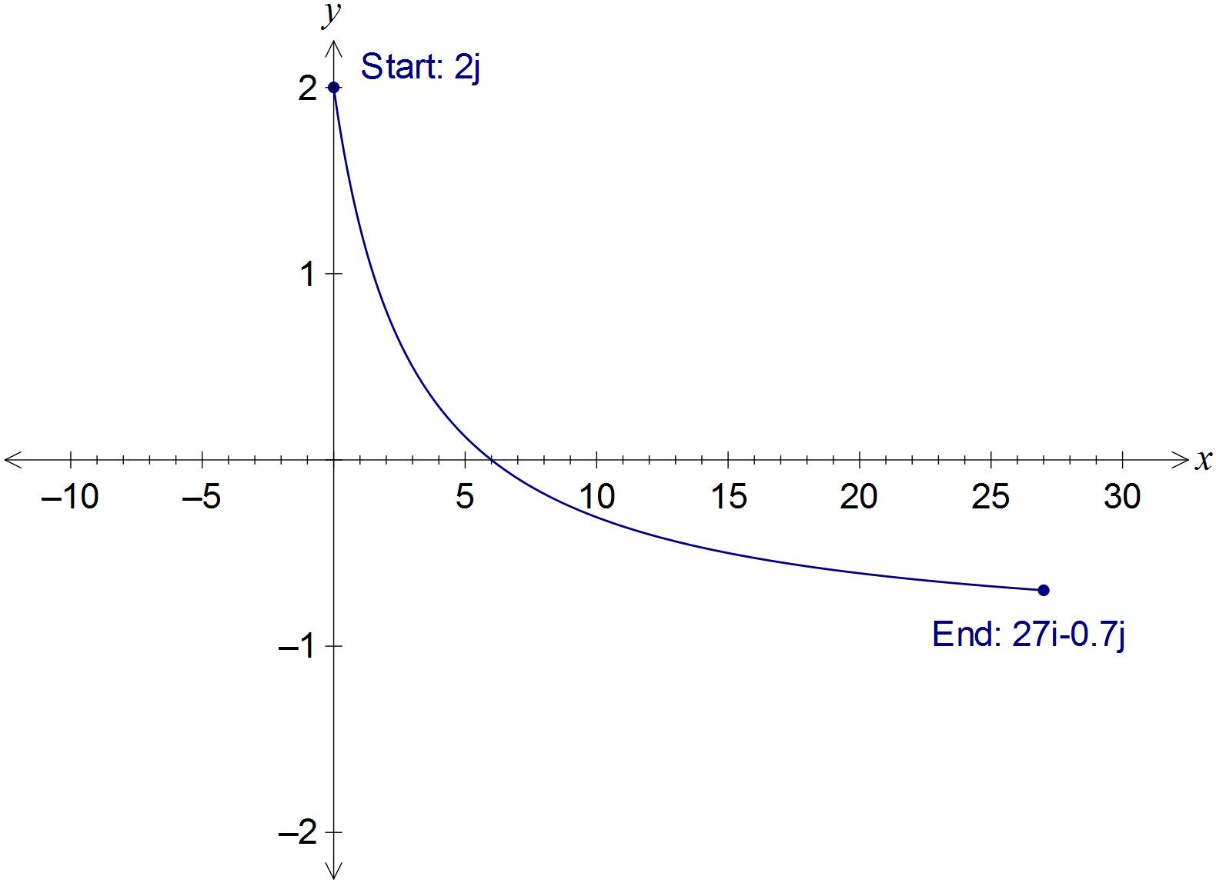

|  |
| --- |
| **Solution** |
| See graph |
| **Specific behaviours** |
| ✓ correct end points marked  ✓ x-intercept at (6, 0)  ✓ smooth curve |

(f) Determine the length of the path travelled by the particle between  and .

(2 marks)

|  |
| --- |
| **Solution** |
|  |
| **Specific behaviours** |
| ✓ writes correct integral  ✓ evaluates integral |

Question 19 (7 marks)

(a) Shade the region satisfying the complex inequality  on the Argand diagram below. (3 marks)

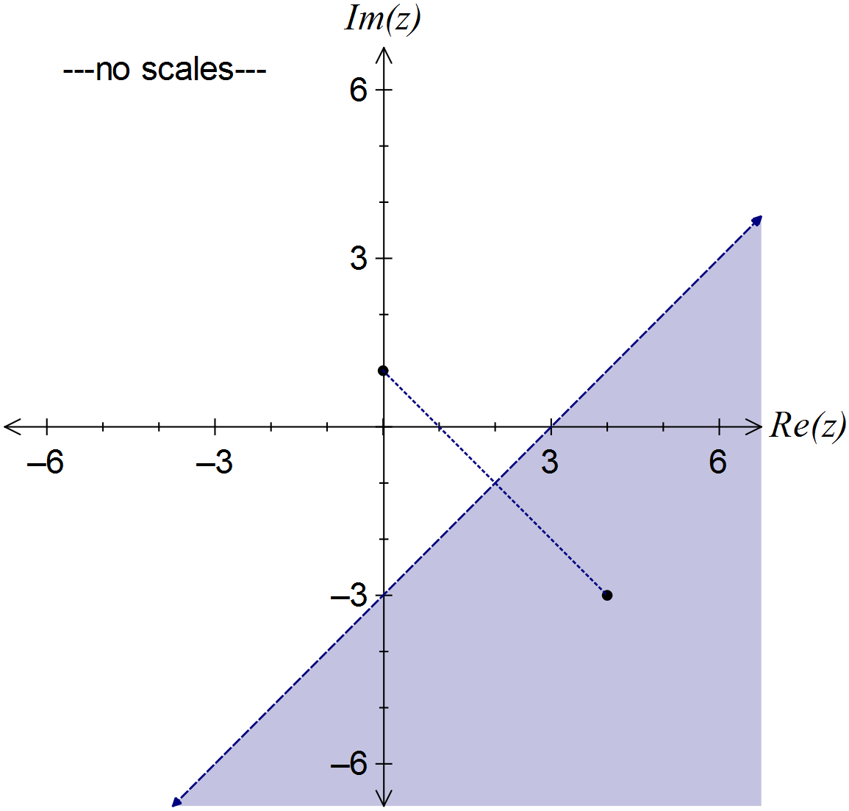

|  |
| --- |
| **Solution** |
| See diagram |
| **Specific behaviours** |
| ✓ adds scale and locates two points  ✓ draws perpendicular bisector of points using dotted line  ✓ shades correct region |

(b) Consider the two complex numbers given by  and . Sketch each of the following sets of points in the complex plane.

(i) . (2 marks)

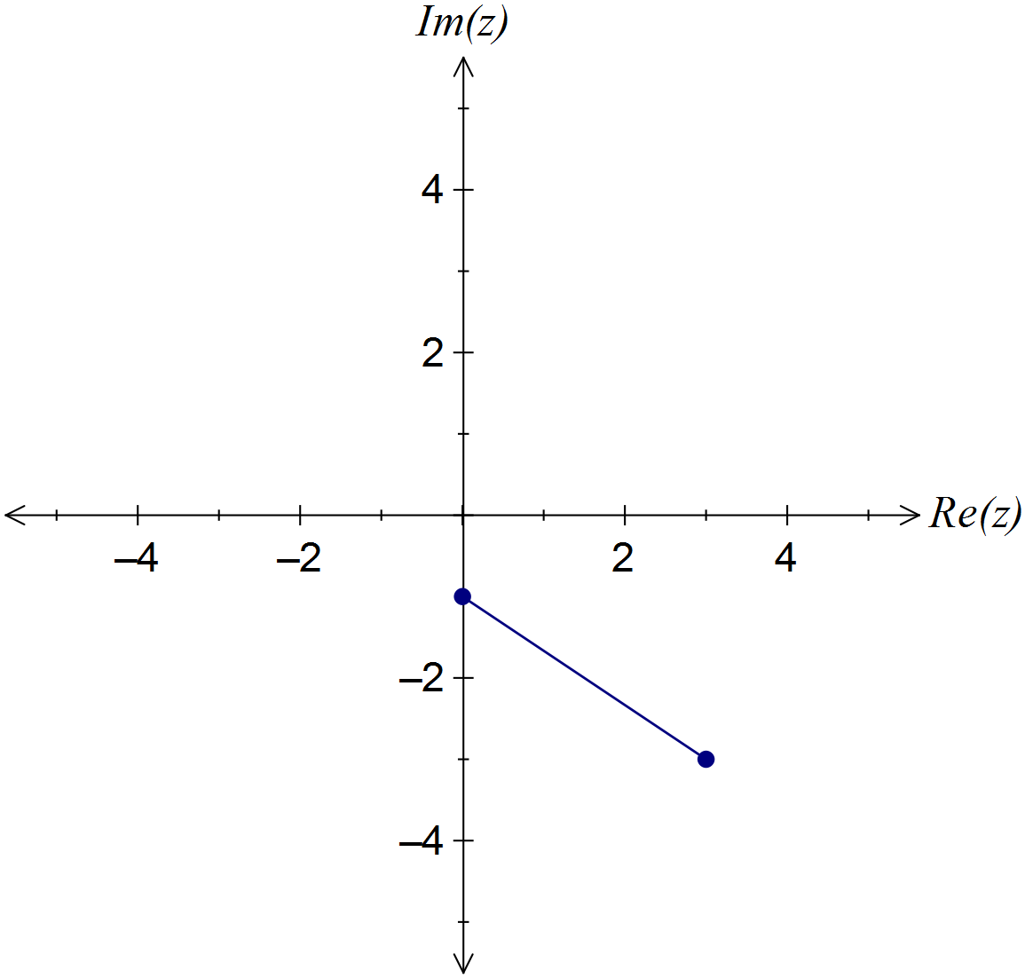

|  |
| --- |
| **Solution** |
| Distance of z from u plus distance of z from v equals distance of u from v |
| **Specific behaviours** |
| ✓ plots end points  ✓ joins end points with straight line |

(ii) . (2 marks)

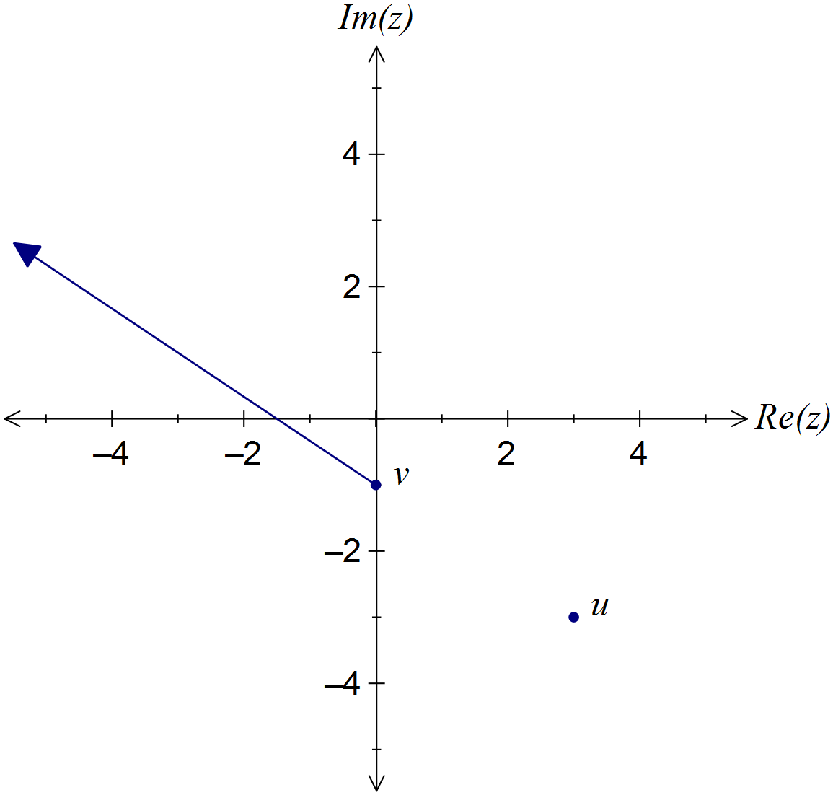

|  |
| --- |
| **Solution** |
| Distance of z from v plus distance of u from v equals distance of z from u |
| **Specific behaviours** |
| ✓ constructs straight line using points  ✓ indicates solution extends from v |

Additional working space

Question number: _________

Additional working space

Question number: _________

Additional working space

Question number: _________

Additional working space

Question number: _________

© 2016 WA Exam Papers. Rossmoyne Senior High School has a non-exclusive licence to copy and communicate this paper for non-commercial, educational use within the school. No other copying, communication or use is permitted without the express written permission of WA Exam Papers.